**1: Transformation (CNF):**

**T:** CNF 1:

**P:** The formula ((p -> q) ^¬q) -> ¬p in CNF is

**A:** True

**T:** CNF 2:

**P:** The formula ((p -> ¬q) ^ ¬q) -> ¬p in CNF is

**A:** (¬p v q)

**T:** CNF 3:

**P:** The formula ((p -> ¬q) ^ ¬q) -> p in CNF is

**A:** (p v q)

**T:** CNF 4:

**P:** The formula ((p -> q) ^ ¬q) -> p in CNF is

**A:** (p v q)

**T:** CNF 5:

**P:** The formula ((p -> ¬q) ^ q) -> ¬p in CNF is

**A:** True

**T:** CNF 6:

**P:** The formula ((p -> ¬q) ^ q) -> p in CNF is

**A:** (p v ¬q)

**T:** CNF 7:

**P:** The formula ((p -> q) ^ q) -> ¬p in CNF is

**A:** (¬p v ¬q)

**T:** CNF 8:

**P:** The formula ((p -> q) ^ q) -> p in CNF is

**A:** (p v ¬q)

**T:** CNF 9:

**P:** The formula ((¬p -> q) ^ q) -> ¬p in CNF is

**A:** (¬p v ¬q)

**T:** CNF 10:

**P:** The formula ((¬p -> q) ^¬q) -> p in CNF is

**A:** True

**T:** CNF 11:

**P:** The formula ((¬p -> q) ^q) -> p in CNF is

**A:** (¬q v p)

**T:** CNF 12:

**P:** The formula ((p ^ q) v ¬q) -> p in CNF is

**A:** (q v p)

**2: Resolution and Resolvent:**

**T:** Resolution 1:

**P:** To prove the soundness of the following statement:

 {~(p∨~q→p),~p→r}⇒r∨~q

we have to prove the inconsistency of the set:

**A:** {p v ¬q, ¬p, p v r, ¬r, q}

**T:** Resolution 2:

**P:** The set of formulas whose inconsistency is equivalent to the soundness of this statement is:

 {~p↔q,q∨r}⇒(~p∧~r)∨r

**A:** {p v q, ¬q v ¬p, q v r, p v r, ¬r}

**T:** Resolution 3:

**P:** Assuming the inconsistency of the following set,

~q,~r∨p,~p∨q, s∨t,~s∨r, r∨~t

Which of the following statements is sound?

**A:** {¬q, ¬p v q, s v t, ¬s v r, r v ¬t} -> r ^ ¬p

**T:** Resolution 4:

**P:** Check if {p v q , ¬p v q, p v ¬q} -> p ^ q is sound using resolution and answer.

**A:** It is sound because the empty clause is obtained

**T:** Resolution 5:

**P:** Check if {¬p v q , p, ¬q v p, ¬q v r, ¬p v ¬r} -> ¬q ^ r is sound using resolution and answer.

**A:** It is sound because the empty clause is obtained

**T:** Resolution 6:

**P:** Check if {p v ¬q , p, ¬p v q, ¬p v r, ¬s, s v t v q, t} -> r is sound using resolution and answer.

**A:** It is sound because the empty clause is obtained

**T:** Resolution 7:

**P:** Check if {p v ¬q , ¬r, ¬p v q, ¬p v r, ¬s, s v t v q, t} -> ¬p is sound using resolution and answer.

**A:** It is sound because the empty clause is obtained

**T:** Resolvent 1:

**P:** A resolvent of p v q and ¬p v ¬q v ¬r is

**A:** True

**T:** Resolvent 2:

**P:** A resolvent of ¬p v q and p v ¬q is

**A:** True

**T:** Resolvent 3:

**P:** A resolvent of ¬p v q and p v ¬q v ¬r is

**A:** True

**T:** Resolvent 4:

**P:** A resolvent of p v ¬q and ¬p v q is

**A:** True

**T:** Resolvent 5:

**P:** A resolvent of p ^ ¬q and ¬p v q is

**A:** It is not possible to compute the resolvent

**T:** Resolvent 6:

**P:** A resolvent of p ^ ¬q and ¬p v q is

**A:** It is not possible to compute the resolvent

**3: Natural Deduction:**

**T:** ND 1:

**P:** To check the soundness of

 P -> ¬q, ¬q ∨ r -> ¬s ⇒ s -> ¬p it is used the following Natural deduction scheme.

**Complete step 6**.

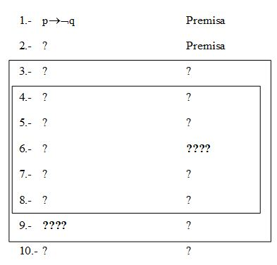

**A:** V i 5

**T:** ND 2:

**P:** Line 15 should be completed as follows:

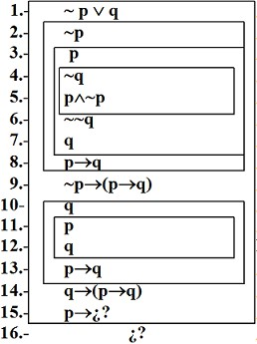

**A:** q V E 1,9,14

**T:** ND 3:

**P:** Complete step 5

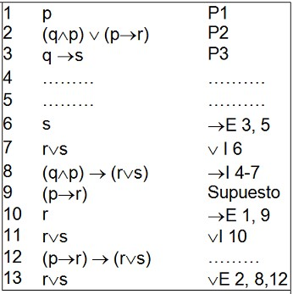

**A:** q ^ E 4

**T:** ND 4:

**P:** To check the soundness of the following statement using ND

**a→b, c→d, a∨c ⇒ b∨d**

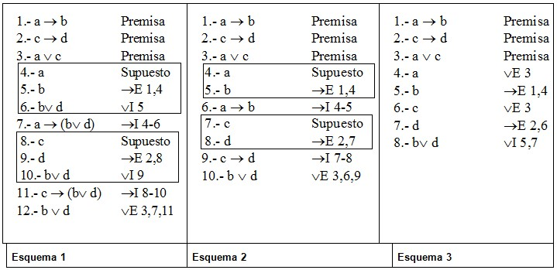

Choose the right ND scheme

**A:** Only scheme 1 is a correct proof

**T:** ND 5:

**P:** Given the ND scheme, choose the correct answer

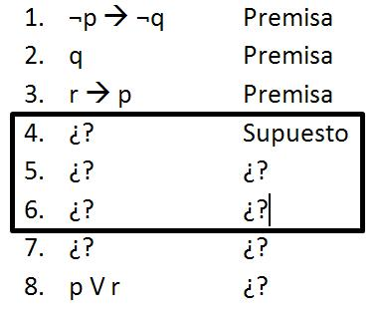

**A:** The rule used in line 7 is ¬E 4-6

**T:** ND 6:

**P:** Given the Natural Deduction scheme, select the right answer

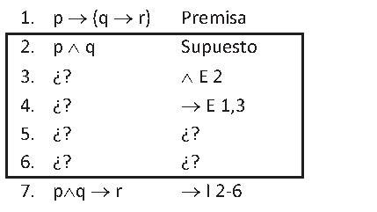

**A:** The formula in line 5 is q and r in line 6

**4: Natural Deduction 2:**

**T:** ND2 1:

**P:** When using natural deduction to prove that

{p, p -> r v s, r -> q, s -> q} -> q

the last step can be an application of

**A:** V E

**T:** ND2 2:

**P:** When using natural deduction to prove that

{p, p -> r ^ s, r -> q, s -> t} -> q ^ t

the last step can be an application of

**A:** ^ i

**T:** ND2 3:

**P:** When using natural deduction to prove that

{p -> r ^ s, r -> q, s -> t} -> p -> q ^ t

the last step can be an application of

**A:** -> i

**T:** ND2 4:

**P:** When using natural deduction to prove that

{p -> r ^ s, r -> q, s -> t} -> p -> q ^ t

the last step can be an application of

**A:** -> i

**T:** ND2 5:

**P:** When using natural deduction to prove that

{p -> r v s, r -> q, s -> q} -> p -> q

the last step can be an application of

**A:** -> i

**T:** ND2 6:

**P:** When using natural deduction to prove that

{p -> r ^ q, ¬q} -> ¬p

the last step can be an application of

**A:** ¬ i

**T:** ND2 7:

**P:** When using natural deduction to prove that

{p -> r ^ q} -> ¬q -> ¬p

the last step can be an application of

**A:** -> i

**T:** ND2 8:

**P:** When using natural deduction to prove that

{p -> r, r -> q, q -> p} -> p <-> q

the last step can be an application of

**A:** <-> i

**T:** ND2 9:

**P:** When using natural deduction to prove that

{r <-> q, q -> p} -> r -> p

the last step can be an application of

**A:** -> i